**Seaborn Plot Details**

**Box Plot :**

* X-axis = Categorical Data (Single Group) -> (Hue Removed Here)
* Y-axis = Numerical Data

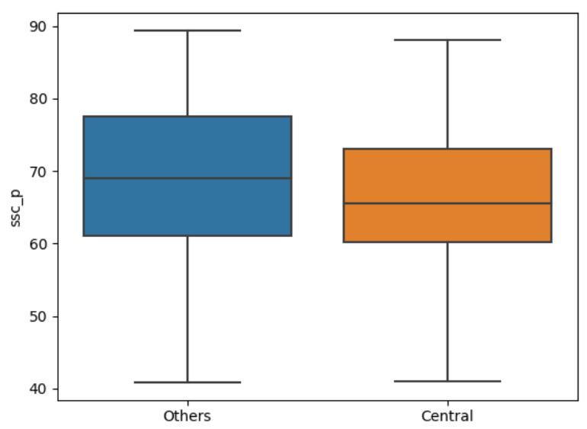

* X-axis = Categorical Data (Two Groups) -> (Hue Not Removed)
* Y-axis = Numerical Data

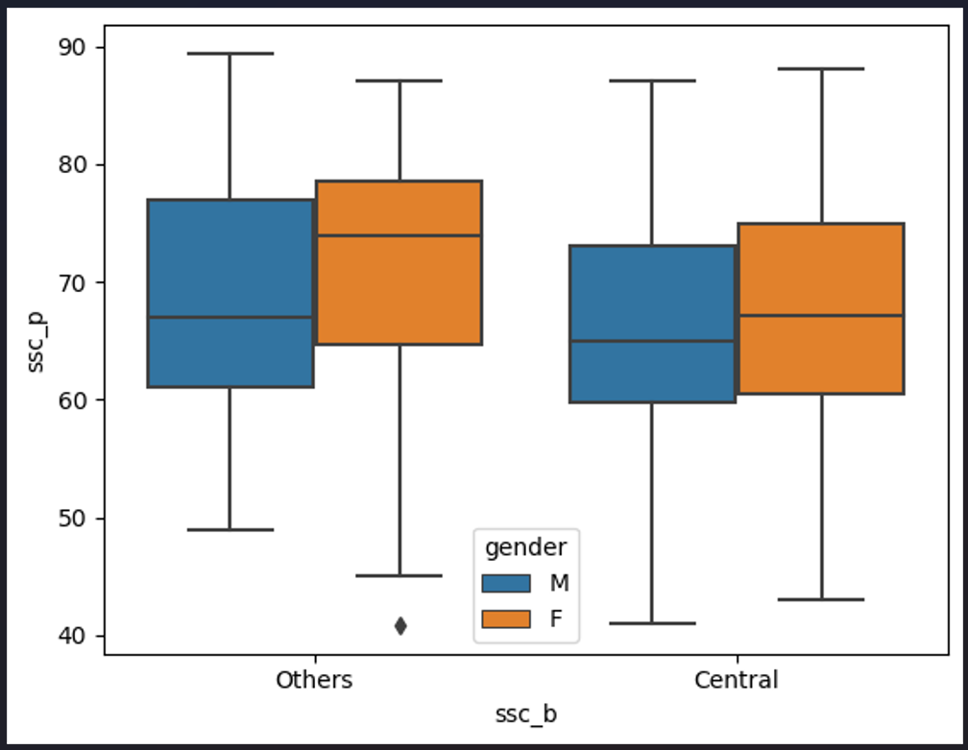

* Box Plot Represents the Concepts of Percentile (Q1, Q2, Q3 and Q4)
* First Line of Box Plot Represents - Q1
* Second Line of Box Plot Represents - Q2
* Third Line of Box Plot Represents - Q3 -> (Broader Line = Median Value)
* Fourth Line of Box Plot Represents - Q4

By Considering the above Points, We can say that

**Category – Others :**

1. **Students – Male :**

* The Initial Value (Q1) of Students - Male starts Nearly 48 (Rounded Off To 50 for Rough Understanding)
* The (Q2) of Students - Male starts Nearly 62 (Rounded Off To 65 for Rough Understanding)
* The (Q3) of Students - Male starts Nearly 67 (Rounded Off To 70 for Rough Understanding)
* The (Q4) of Students - Male starts Nearly 78 (Rounded Off To 80 for Rough Understanding)

1. **Students – Female :**

* The Initial Value (Q1) of Students - Female starts Nearly 35
* The (Q2) of Students - Female starts Nearly 65
* The (Q3) of Students - Female starts Nearly 73 (Rounded Off To 75 for Rough Understanding)
* The (Q4) of Students - Female starts Nearly 79 (Rounded Off To 80 for Rough Understanding)

**Category – Central :**

1. **Students – Male :**

* The Initial Value (Q1) of Students - Male starts Nearly 44 (Rounded Off To 45 for Rough Understanding)
* The (Q2) of Students - Male starts Nearly 60
* The (Q3) of Students - Male starts Nearly 65
* The (Q4) of Students - Male starts Nearly 72 (Rounded Off To 75 for Rough Understanding)

1. **Students – Female :**

* The Initial Value (Q1) of Students - Female starts Nearly 35
* The (Q2) of Students - Female starts Nearly 62 (Rounded Off To 65 for Rough Understanding)
* The (Q3) of Students - Female starts Nearly 68 (Rounded Off To 70 for Rough Understanding)
* The (Q4) of Students - Female starts Nearly 73 (Rounded Off To 75 for Rough Understanding)

**Cat Plot (Previously Known as Factor Plot) :**

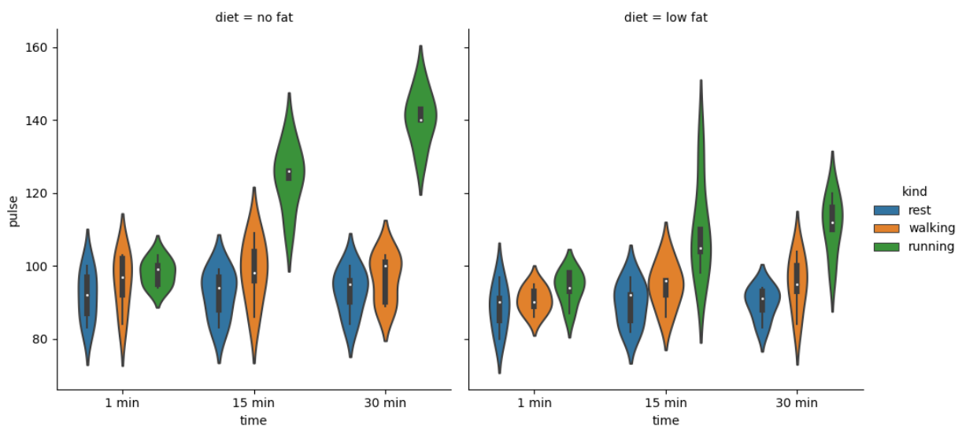

* Cat Plot shows the Distribution of Dataset Passed (Used an Inbuild Dataset - exercise from Library – seaborn) and this Dataset talks about the Exercise activities of People those performed the Exercises
* Parameter of this Plot is (x = "time", y = "pulse", hue = "kind", kind = 'violin', col = "diet", data = df)
* This Plot Groups the Data by Time Taken (In Mins) for Specified activities (Rest, Walking and Running) in X-Axis and Pulse rate in Y-Axis
* The Activities has been differentiated through Colours Rest = Blue, Walking = Orange and Running = Green
* Overall Graphs has been plotted into Two Types of Diet : 1. No Fat and 2. Low Fat

**Type – 01 : Diet = No Fat -> 01 Min**

* **Activity-01 : Rest,** shows that Pulse Rate Ranges between 75 To 110 Beats / Per Minute and a Broadened Distribution for Dense Data Ranges between 85 To 105 Beats / Per Minute
* **Activity-02 : Walking,** shows that Pulse Rate Ranges between 75 To 115 Beats / Per Minute and a Broadened Distribution for Dense Data Ranges between 90 To 110 Beats / Per Minute
* **Activity-03 : Running,** shows that Pulse Rate Ranges between 90 To 105 Beats / Per Minute and a Broadened Distribution for Dense Data Ranges between 95 To 105 Beats / Per Minute

**Type – 01 : Diet = No Fat -> 15 Mins**

* **Activity-01 : Rest,** shows that Pulse Rate Ranges between 75 To 105 Beats / Per Minute and a Broadened Distribution for Dense Data Ranges between 85 To 100 Beats / Per Minute
* **Activity-02 : Walking,** shows that Pulse Rate Ranges between 75 To 120 Beats / Per Minute and a Broadened Distribution for Dense Data Ranges between 90 To 115 Beats / Per Minute
* **Activity-03 : Running,** shows that Pulse Rate Ranges between 100 To 145 Beats / Per Minute and a Broadened Distribution for Dense Data Ranges between 110 To 130 Beats / Per Minute

**Type – 01 : Diet = No Fat -> 30 Mins**

* **Activity-01 : Rest,** shows that Pulse Rate Ranges between 78 To 108 Beats / Per Minute and a Broadened Distribution for Dense Data Ranges between 85 To 105 Beats / Per Minute
* **Activity-02 : Walking,** shows that Pulse Rate Ranges between 80 To 110 Beats / Per Minute and a Broadened Distribution for Dense Data Ranges between 85 To 105 Beats / Per Minute
* **Activity-03 : Running,** shows that Pulse Rate Ranges between 120 To 155 Beats / Per Minute and a Broadened Distribution for Dense Data Ranges between 130 To 150 Beats / Per Minute

**Type – 02 : Diet = Low Fat -> 01 Min**

* **Activity-01 : Rest,** shows that Pulse Rate Ranges between 60 To 105 Beats / Per Minute and a Broadened Distribution for Dense Data Ranges between 70 To 90 Beats / Per Minute
* **Activity-02 : Walking,** shows that Pulse Rate Ranges between 80 To 95 Beats / Per Minute and a Broadened Distribution for Dense Data Ranges between 90 To 110 Beats / Per Minute
* **Activity-03 : Running,** shows that Pulse Rate Ranges between 78 To 103 Beats / Per Minute and a Broadened Distribution for Dense Data Ranges between 90 To 100 Beats / Per Minute

**Type – 02 : Diet = Low Fat -> 15 Mins**

* **Activity-01 : Rest,** shows that Pulse Rate Ranges between 70 To 103 Beats / Per Minute and a Broadened Distribution for Dense Data Ranges between 75 To 95 Beats / Per Minute
* **Activity-02 : Walking,** shows that Pulse Rate Ranges between 78 To 110 Beats / Per Minute and a Broadened Distribution for Dense Data Ranges between 85 To 105 Beats / Per Minute
* **Activity-03 : Running,** shows that Pulse Rate Ranges between 80 To 150 Beats / Per Minute and a Broadened Distribution for Dense Data Ranges between 90 To 120 Beats / Per Minute

**Type – 02 : Diet = Low Fat -> 30 Mins**

* **Activity-01 : Rest,** shows that Pulse Rate Ranges between 75 To 95 Beats / Per Minute and a Broadened Distribution for Dense Data Ranges between 80 To 98 Beats / Per Minute
* **Activity-02 : Walking,** shows that Pulse Rate Ranges between 70 To 110 Beats / Per Minute and a Broadened Distribution for Dense Data Ranges between 80 To 105 Beats / Per Minute
* **Activity-03 : Running,** shows that Pulse Rate Ranges between 90 To 130 Beats / Per Minute and a Broadened Distribution for Dense Data Ranges between 100 To 125 Beats / Per Minute